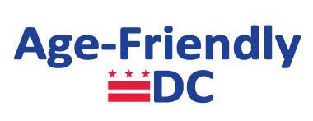

The Age-Friendly DC Initiative is part of an international effort started by the World Health Organization (WHO) to respond to two significant demographic trends: urbanization and population aging. As of 2007, over half of the world’s population lived in cities and by 2030 that population will rise to about three out of every five people in the world. At the same time, improvements in public health have led to more people living longer lives. The proportion of people aged 60 and over will likely double from 11 percent of the world’s population in 2006 to 22 percent by 2050. To help cities prepare for the convergence of these two trends, the WHO developed the Global Age-Friendly Cities project. WHO maintains eight broad domains that help influence the health and quality of life of older people living all around the world. The District of Columbia has included two additional domains for a total of 10 domains:

- Outdoor Spaces and Buildings - accessibility to and availability of safe recreational facilities.
- Transportation - safe and affordable modes of private and public transportation.
- Housing - wide range of housing options for older residents, aging in place, and other home modification programs.
- Social Participation - access to leisure and cultural activities and opportunities for older residents to participate in social and civic engagement with their peers and younger people.
- Respect and Social Inclusion - programs to support and promote ethnic and cultural diversity, along with programs to encourage multigenerational interaction and dialogue.
- Civic Participation and Employment - promotion of paid work and volunteer activities for older residents and opportunities to engage in formulation of policies relevant to their lives.
- Communication and Information - promotion of and access to the use of technology to keep older residents connected to their community and friends and family, both near and far.
- Community Support and Health Services - access to homecare services, clinics, and programs to promote wellness and active aging.
- Emergency Preparedness and Resilience, a DC focus - information, education and training to ensure the safety, wellness, and readiness of seniors in emergency situations.
- Elder Abuse, Neglect, and Fraud, a DC focus - prevention and prosecution of financial exploitation, neglect, and physical, sexual, and emotional abuse of seniors.

