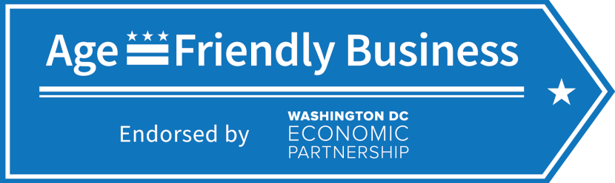

2014 Age-Friendly Businesses

Business | Address | Ward
- C.A.T. Walk Boutique | 1000 H Street N.E. | 6
- Center for Nonprofit Advancement | 1666 K St NW #440 | 2
- DC Dragons Martial Arts Training Center | 1731 Rhode Island Ave NE, Washington, DC 20018 | 5
- Pepco | 701 9th St NW | 2
- Renee by Boddie’s Unisex Salon | 3505 Georgia Ave NW | 1
- Rockland’s Barbeque and Grilling Company | 2418 Wisconsin Ave NW | 3
- Rorschach Theater | 1333 H Street NE  Washington DC 20002 | 6
- Taurus Renovation Consultants, Inc. | 1341 H St NE | 6
- Union Town Bar & Grill | 2200 Martin Luther King Jr Ave SE, | 8
- Verizon | 1300 I St. NW, Suite 400 West | 2
- Zekes Coffee of DC | 2300 Rhode Island Ave NE | 5

2016 Age-Friendly Businesses

Business | Location | Ward
- All N' 1 Medical Supplies & Treasures, LLC | 5119 Nannie Helen Burroughs Avenue, NE Suite A | 7
- Annie’s Ace Hardware | 1240 Upshur St. NW | 4
- ArtJamz | 1728 Connecticut Ave NW, Washington, D.C. 20009 | 2
- Balance Gym - Glover Park | 2121 Wisconsin Ave NW | 3
- Bene' Millinery & Bridal Supplies | 6217 3rd St NW | 4
- Busboys and Poets – 14th & V | 2021 14th St, NW  Washington, D.C. 20009 | 1
- Busboys and Poets – 5th & K | 1025 5th Street NW  Washington, DC 20001 | 6
- Busboys and Poets - Brookland | 625 Monroe St NE | 5
- Busboys and Poets -Takoma | 235 Carroll St NW  Washington, DC 20012 | 4
- Capitol Living LLC | 804 E street NE | 6
- Crystal Insurance Agency | 1805 Belmont Road NW, Suite 105 | 1
- CVS Pharmacy | 110 Carroll St NW | 4
- Denny's | 4445 Benning Rd. NE | 7
- Ethio USA Tours | 1380 Monroe St NW# 626 Washington Dc 20010 | 1
- Forest Hills of DC | 4901 Connecticut Ave. NW Washington, DC 20008 | 3
- Georgetown Long & Foster Real Estate | 1680 Wisconsin Avenue, NW Washington DC 20007 | 2
- Institutional Dental Care, Inc. | 3100 20th St., NE, Washington, DC 20018 | 5
- Lawrence Executive Alliance of Professionals (LEAP), LLC | 1111 23rd St NW, Suite 2G, Washington, D.C., 20037 | 2
- Ledo's Pizza | 7435 Georgia Ave NW DC 20012 | 4
- Mint Dental | 329 Rhode Island Ave. NE, Suite A | 5
- Mr & Mrs Snider Real Estate | 5815 4th Street, NW Washington, DC 20011 | 4
- Plush Beauty Box | 3617 12th St NE Washington, DC 20017 | 5
- Safeway | 6500 Piney Branch Rd NW | 4
- Secondi | 1702 Connecticut Avenue, NW Washington, D.C. 20009 - Second Floor | 2
- Smith & Sons LLC | 1801 Clydesdale Place, NW Suite 710 | 1
- Solar City | 840 First St. NE 20002 | 6
- Stoddard Baptist Nursing Home | 1818 Newton Street, NW | 1
- Total Healthcare Solutions | 38 Porter Street NE, Washington, DC, 20002 | 5
- Total Relaxation Store | 3124 12th Street, NE, Washington, D.C 20017 | 5
- University Professional and Continuing Education Association | 1 Dupont Circle | 2
- Washington Center for Aging Services | 2601 18th St. NE | 5
- Yoga Heights | 3506 Georgia Ave. NW | 1

