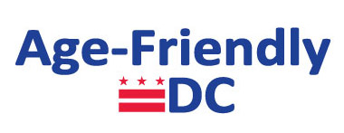

Age-Friendly DC Task Force Meeting

Meeting Agenda
Marvin Center, 800 21st Street, NW, George Washington University
Room 407

February 23, 2017

8:45 - 10:45am
- Call to order
- New Business
- Swearing In by Mayor’s Office of Talent and Appointments – HyeSook Chung, DC Deputy Mayor for Health and Human Services as Task Force Co-Chair
- Task Force Committee Updates and Discussion
- Age-Friendly DC Presentation: Review and Update of Timeline thru June 2017
- Old Business
- Upcoming age-friendly events/announcements
- Public comment period
- Calendar update
- Adjournment

Future Task Force Meetings

6/15/2017 from 10:00 AM- Noon , JAWB, TBA

9/228/2017 from 10:00 AM- Noon, GWU, TBA

11/16/2017 from 10:00 AM – Noon, JAWB, TBA

