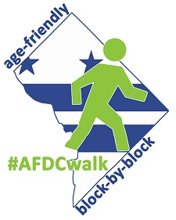
Age-Friendly DC
Block-by-Block Walk
Vision Zero Instructions

Open the Vision Zero map from a browser. Go to http://visionzero.ddot.dc.gov/VisionZero/ and wait for map to load.

Navigate to wherever you notice unsafe behavior or infrastructure and enter it on the map.

You can enter information on:
- Not enough time to cross - Pedestrians don’t have enough time to cross the street during the "Walk" signal.
- Double parking - Many vehicles are parked in moving lanes.
- Long wait to cross - Pedestrians need to wait too long to receive the "Walk" signal.
- Red light running - Many drivers don’t stop at a red light or a stop sign.
- Jaywalking - Many pedestrians cross the street against the signal or in the middle of the block.
- Poor visibility - Drivers and pedestrians have difficulty seeing each other.
- Speeding - Many drivers travel above the speed limit.
- Long distance to cross - The road is too wide to cross comfortably and/or there aren’t safe areas where pedestrians can wait if the signal changes to "Don’t Walk".
- Failure to stop for pedestrians - Drivers turning into the crosswalk don’t yield to crossing pedestrians.
- Cyclist behavior - Many cyclists do not yield to pedestrians, bike against the flow of traffic, ignore traffic signals or other issues.
- Blocking the bikebox - Blocking the bikebox.
- Blocking the crosswalk - Blocking the crosswalk.
- Stop sign running - Stop sign running.
- Accessibility Issue - Accessibility Issue.
- Other Biking Issue - Other Biking Issue.
- Other Driving Issue - Other Driving Issue.
- Other Walking Issue - Other Walking Issue.

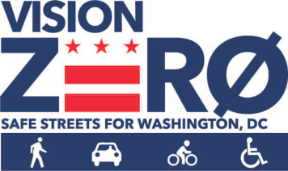
If the online map is not working, enter the number (above) of what you see on your paper map and go to the website later to enter the information.

